

**Software Design Specification**

**[****Grocery Shop Management System]**

**Project - ICT 2212**

**Bachelor of Information and Communication Technology**

**(BICT)**

**Degree Programme**

Department of Information and Communication Technology

Faculty of Technology

Rajarata University of Sri Lanka Mihintale

**Details of the Research Project**

Title : Grocery Shop Management System

Group Number : 01

Group Name : Techno

Submission Date : 29.04.2024

Group Members :

|  |  |  |
| --- | --- | --- |
| Student Name | Index Number | Signature |
| P.W.D.I.M Rodrigo | 1357 |  |
| H.M.M.A Herath | 1313 |  |
| G.P Rockshan | 1356 |  |
| P.H.M.T Perera | 1344 |  |
| A.R.M Najas | 1335 |  |

Internal supervisor

Name : Ms. Oshadhi Munasinghe

Designation : Lecturer (Temporary)

Department : Information and Communication Technology

Email : okmunasi@tec.rjt.ac.lk

Signature : ________________ Date: 29.04.2024

**Table of Contents**

1. Introduction 5

1.1. Introduction 5

1.2. Problem Statement 5

1.3. Aim 5

1.4. Objectives 5

1.5. Significance of the Project 5

1.6. Project Work Plan 6

1.7. Assumptions and Limitations 6

2. Approach 7

2.1. Scope 7

2.2. Organization 7

2.3. Project Type 7

2.4. End Users of the Project 7

2.5. Feasibility Study 7

2.6. Rich Picture 7

3. Analysis 8

3.1. Data Gathering 8

3.2. Analysis of Gathered Data 8

3.3. Extant System 8

3.4. Requirement Specification 8

4. Design 9

4.1. System Model 9

4.1.1. Use Case Diagram 9

4.1.2. Class Diagram 10

4.1.3. Activity Diagrams 11

4.1.4. Sequence Diagrams 12

4.2. System Architecture 12

4.2.1. Presentation Layer 12

4.2.2. Application Layer 12

4.2.3. Database Layer 12

4.3. Database Design 12

4.3.1. Entity Relationship Diagram 13

4.3.2. Schema Diagram 14

4.3.3. Interface Design 15

5. Development 19

5.1. Solution 19

5.2. Technology Adopted 19

6. Testing and Evaluation 20

6.1. Testing Plan 20

6.2. Testing Results and Conclusion 20

7. Conclusion 21

7.1. Conclusions of the Project 21

7.2. Lessons Learned and Skills Earned 21

7.3. Recommendations for Improvements 21

8. References and Appendixes 22

8.1. References 22

8.2. Appendixes 22

**List of Tables**

No table of figures entries found.

**List of Figure**

Figure 1 Use Case Diagram 10

Figure 2 Class Diagram 11

Figure 3 Activity Diagrams 12

Figure 4 ER Diagram 14

Figure 5 Interface Design: Home 16

Figure 6 Interface Design: Cashier Login 16

Figure 7 Interface Design: Manager Login 17

Figure 8 Interface Design: Cashier dashboard 17

Figure 9 Interface Design: Manager dashboard 18

Figure 10 Interface Design: Manager Add Product 18

Figure 11 Interface Design: Manager Add Cashier 19

# 1. Introduction

## 1.1. Introduction

In today's retail world, running a grocery store is getting tougher. Traditional ways of keeping track of what's in stock, how much is sold, and managing suppliers are falling short. This project aims to fix that by creating a special system just for grocery stores. This system, called Grocery Shop Management System (GSMS), will make running a store much easier by using technology to handle everyday tasks better.

## 1.2. Problem Statement

Running a grocery store comes with its own set of challenges. Inventory records are often incomplete, suppliers are hard to manage, and there's a lack of coordination between different parts of the business. This makes it hard for store owners to make good decisions and keep their stores running smoothly. Without a good system in place, grocery stores can struggle to keep up with the competition.

## 1.3. Aim

This project aims to create a GSMS that fits the needs of grocery stores perfectly. By making it easy to use and tailored to the needs of supermarket owners, we hope to make running a store much simpler. The GSMS will help store owners keep track of what they have in stock, analyze sales trends, and manage suppliers more effectively.

## 1.4. Objectives

1. **Develop a Comprehensive GSMS**: Create a Grocery Shop Management System that covers all aspects of running a grocery store, including inventory management, sales analysis, and supplier management.
2. **Empower Informed Decision-Making**: Provide store owners with accurate and timely information about their inventory levels, sales trends, and supplier interactions, enabling them to make data-driven decisions that optimize their operations.
3. **Enhance Operational Efficiency**: Streamline day-to-day processes such as inventory tracking, order management, and sales reporting to improve overall efficiency and productivity in grocery store operations.

## 1.5. Significance of the Project

The success of this project holds substantial significance for the grocery retail industry:

1. **Operational Streamlining**: By automating manual tasks and integrating various operational functions into a single system, the GSMS can significantly streamline grocery store operations, reducing administrative burdens and increasing productivity.
2. **Competitive Edge**: Grocery stores equipped with an advanced management system can gain a competitive edge in the market by offering superior customer service, optimizing inventory levels, and responding quickly to changing consumer demands.
3. **Cost Savings**: Efficient inventory management and optimized procurement processes facilitated by the GSMS can lead to cost savings for store owners through reduced instances of overstocking, minimized wastage, and improved supplier negotiations.
4. **Customer Satisfaction**: With better inventory visibility and streamlined checkout processes, the GSMS can enhance the overall shopping experience for customers, leading to increased satisfaction and loyalty.
5. **Long-Term Viability**: In the rapidly evolving retail landscape, the adoption of innovative technology solutions like the GSMS is crucial for the long-term sustainability and growth of grocery stores, ensuring they remain competitive and relevant in the digital age.

## 1.6. Project Work Plan

## 1.7. Assumptions and Limitations

# 2. Approach

## 2.1. Scope

## 2.2. Organization

## 2.3. Project Type

## 2.4. End Users of the Project

## 2.5. Feasibility Study

## 2.6. Rich Picture

# 3. Analysis

## 3.1. Data Gathering

## 3.2. Analysis of Gathered Data

## 3.3. Extant System

## 3.4. Requirement Specification

# 4. Design

## 4.1. System Model

### 4.1.1. Use Case Diagram

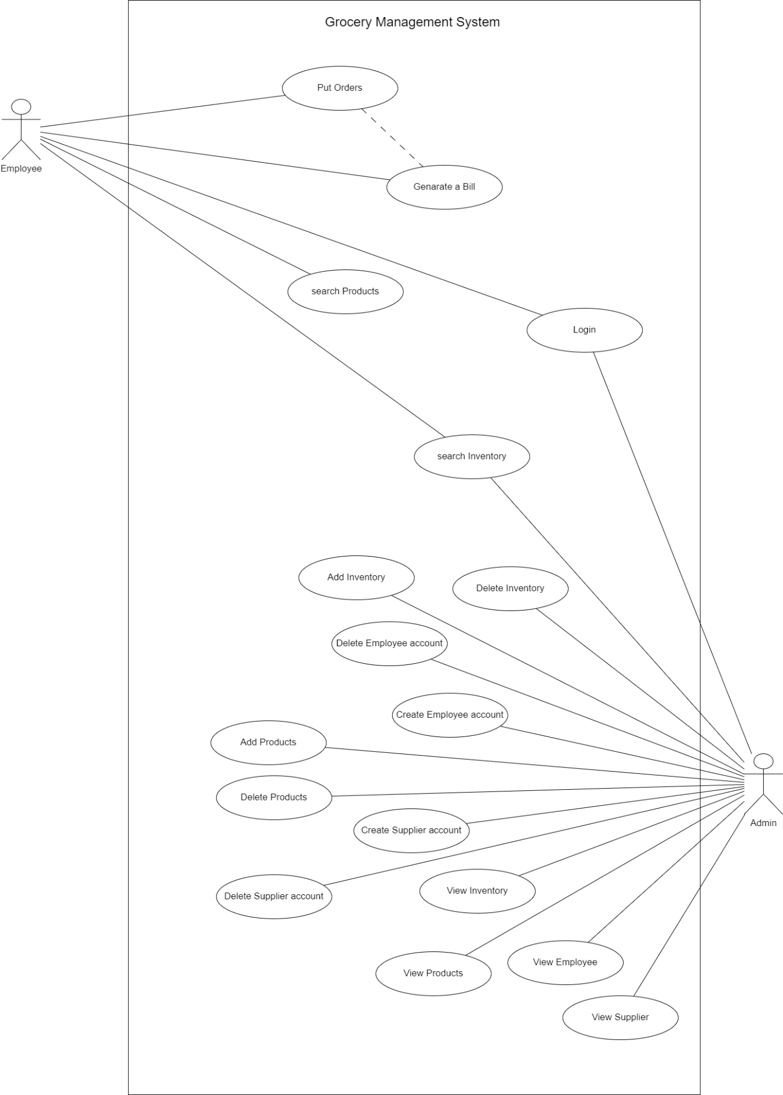

Figure 1 Use Case Diagram

### 4.1.2. Class Diagram

Figure 2 Class Diagram

### 4.1.3. Activity Diagrams

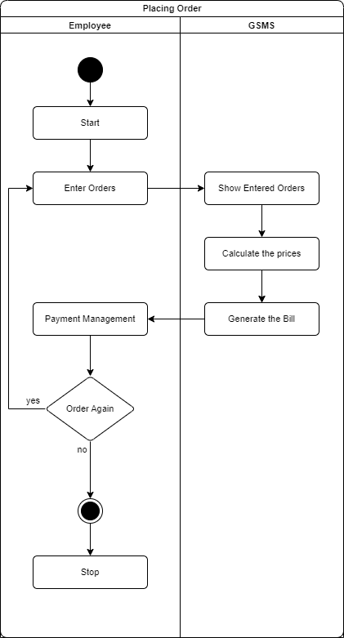

Figure 3 Activity Diagrams

### 4.1.4. Sequence Diagrams

## 4.2. System Architecture

### 4.2.1. Presentation Layer

### 4.2.2. Application Layer

### 4.2.3. Database Layer

## 

## 4.3. Database Design

### 4.3.1. Entity Relationship Diagram

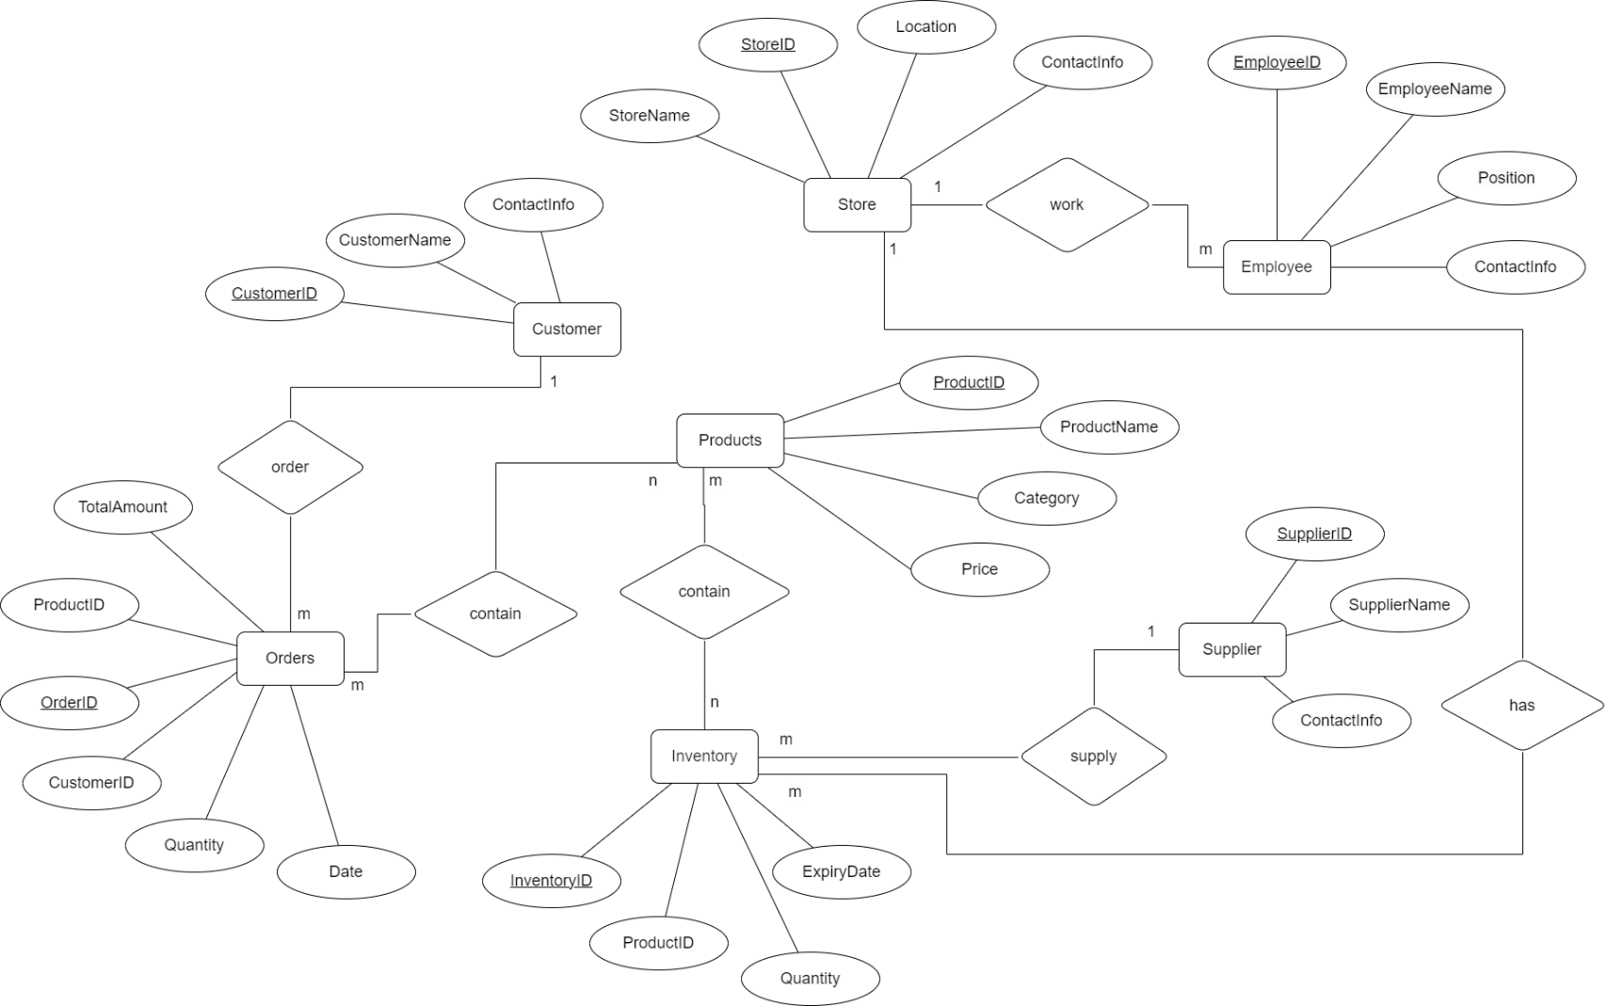

Figure 4 ER Diagram

### 4.3.2. Schema Diagram

### 4.3.3. Interface Design

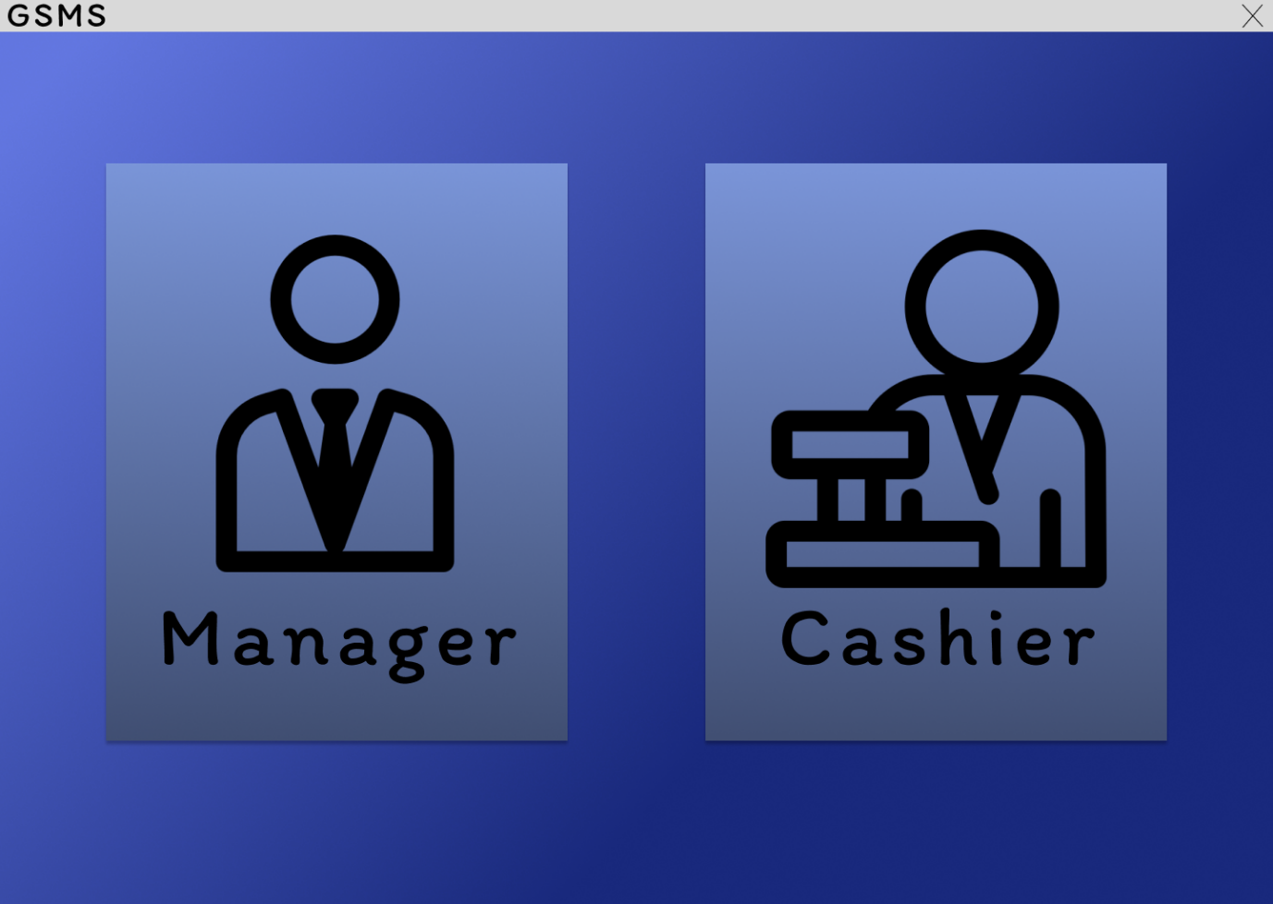

Figure 5 Interface Design: Home

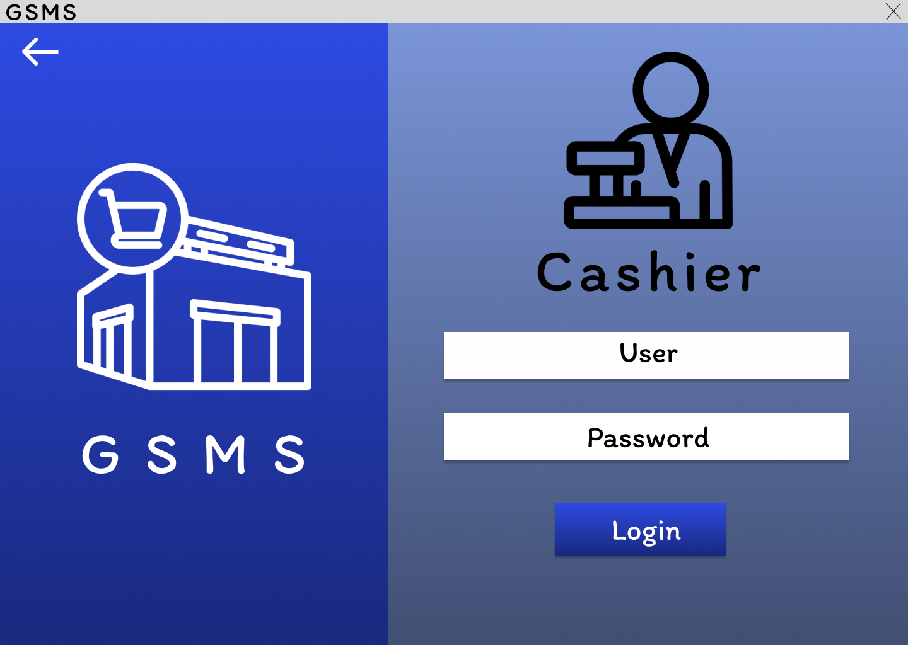

Figure 6 Interface Design: Cashier Login

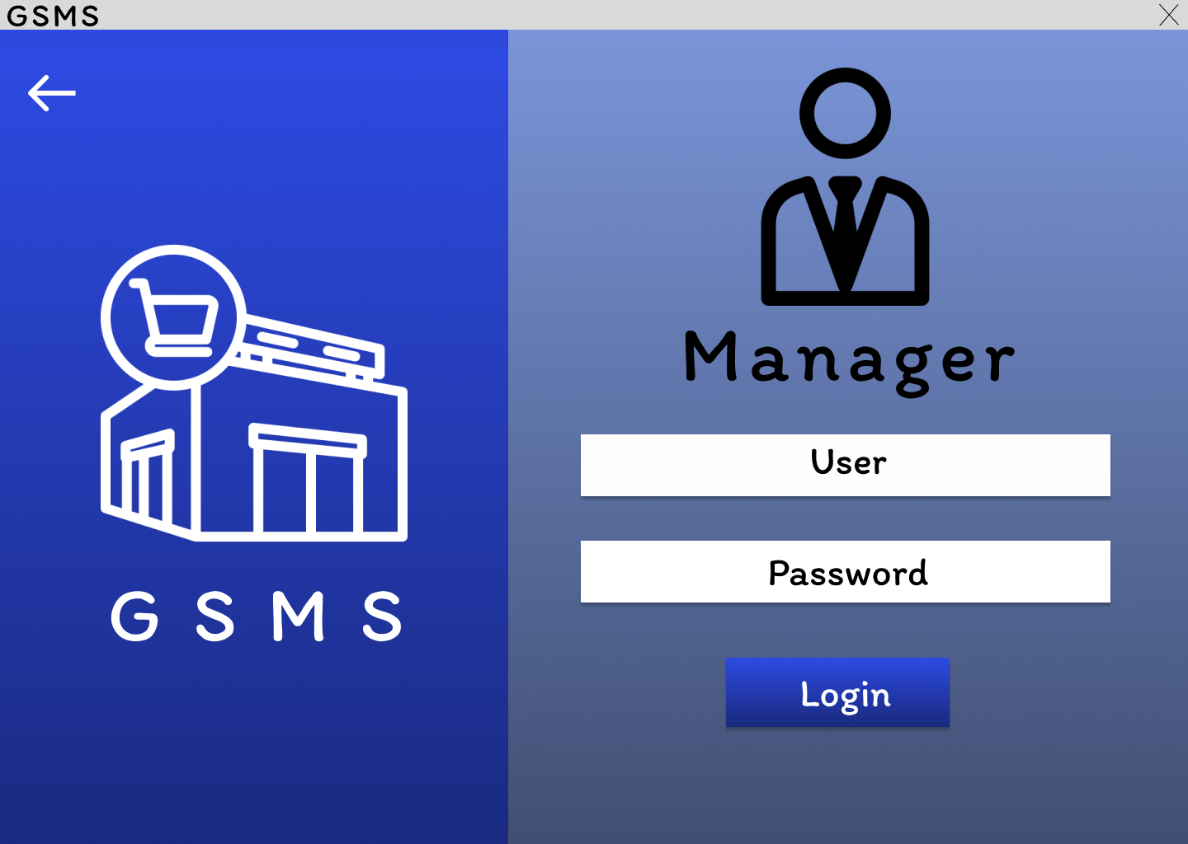

Figure 7 Interface Design: Manager Login

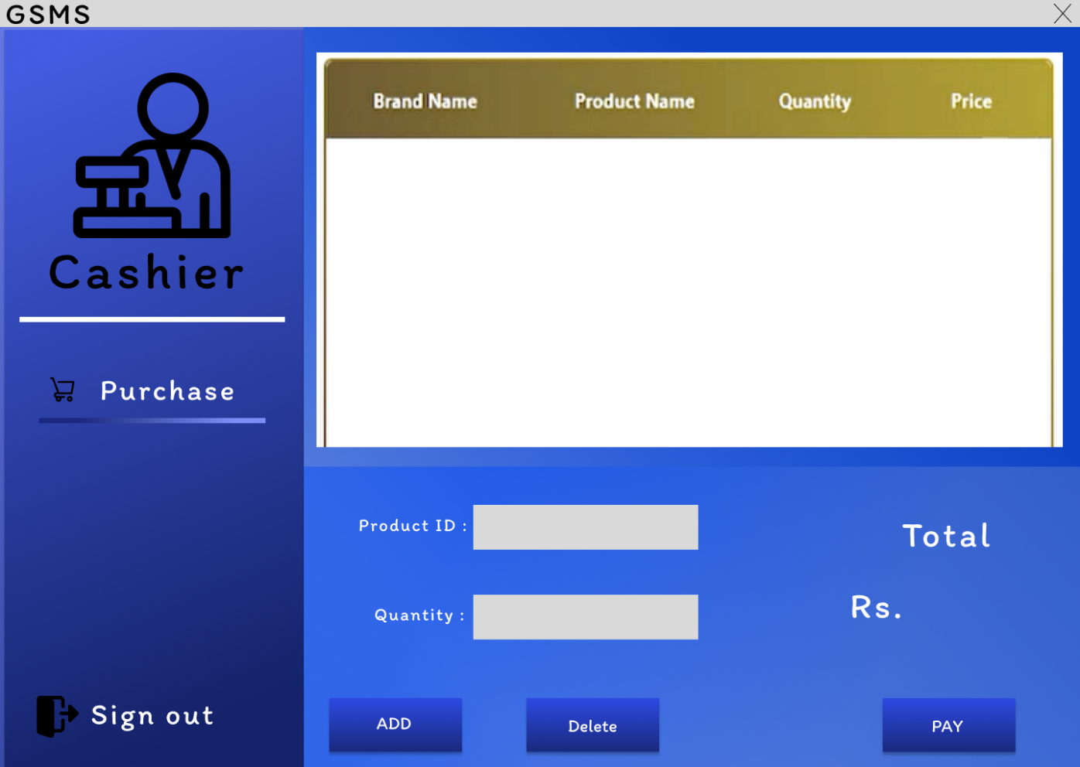

Figure 8 Interface Design: Cashier dashboard

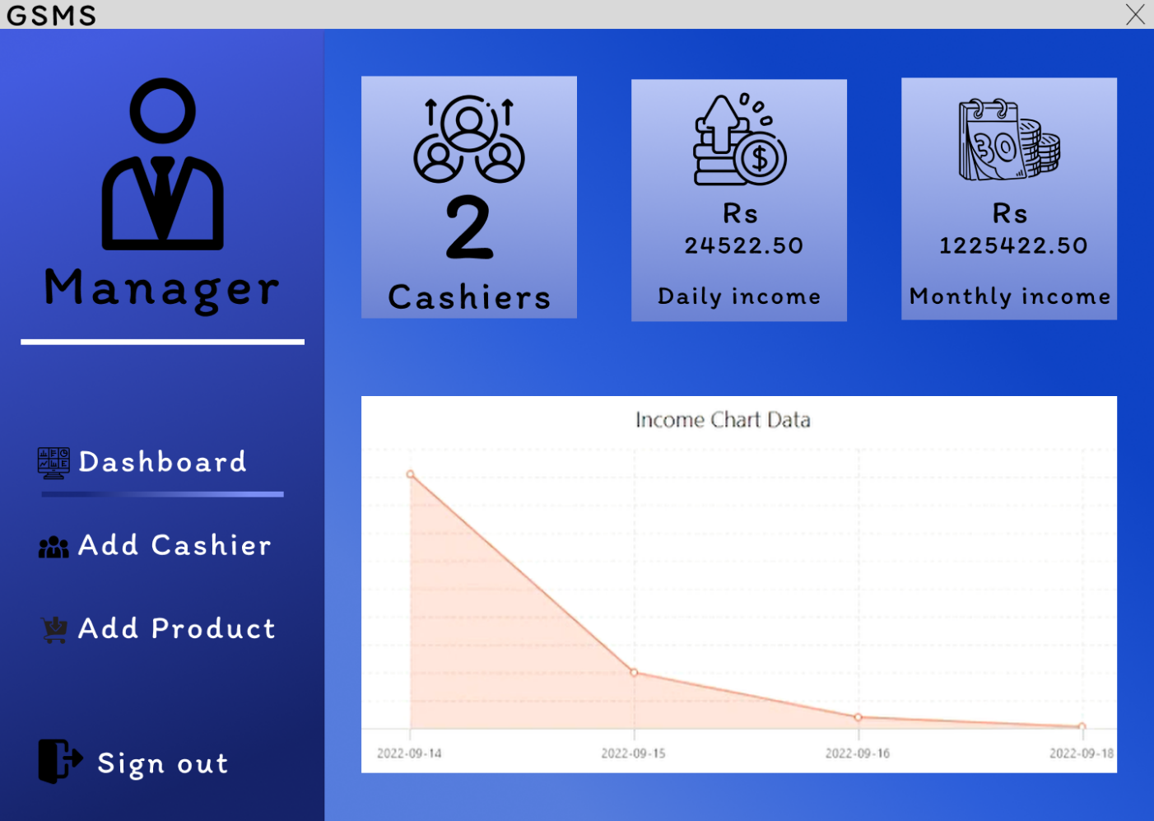

Figure 9 Interface Design: Manager dashboard

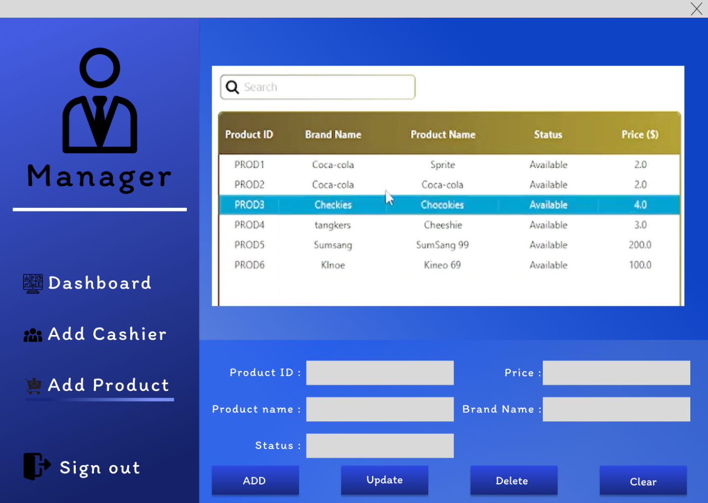

Figure 10 Interface Design: Manager Add Product

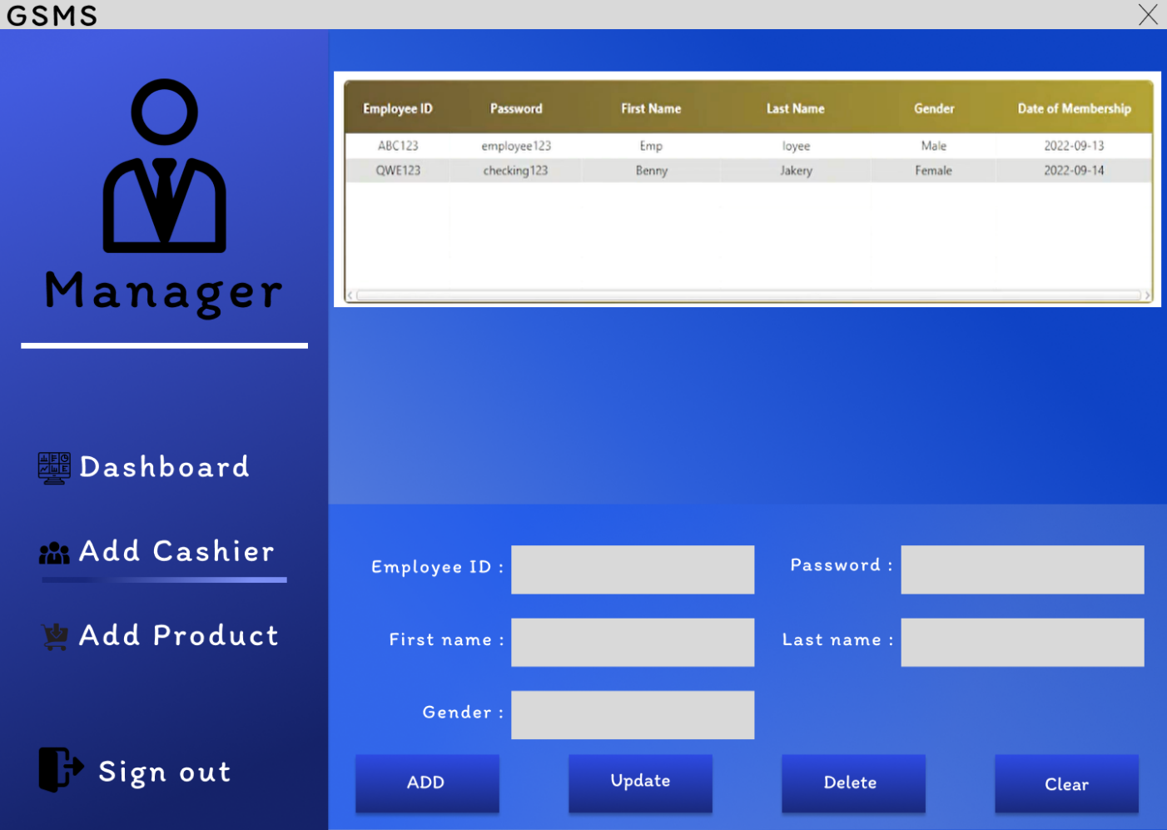

Figure 11 Interface Design: Manager Add Cashier

# 5. Development

## 5.1. Solution

## 5.2. Technology Adopted

# 6. Testing and Evaluation

## 6.1. Testing Plan

## 6.2. Testing Results and Conclusion

# 7. Conclusion

## 7.1. Conclusions of the Project

## 7.2. Lessons Learned and Skills Earned

## 7.3. Recommendations for Improvements

# 8. References and Appendixes

## 8.1. References

## 8.2. Appendixes